# iPhone 11

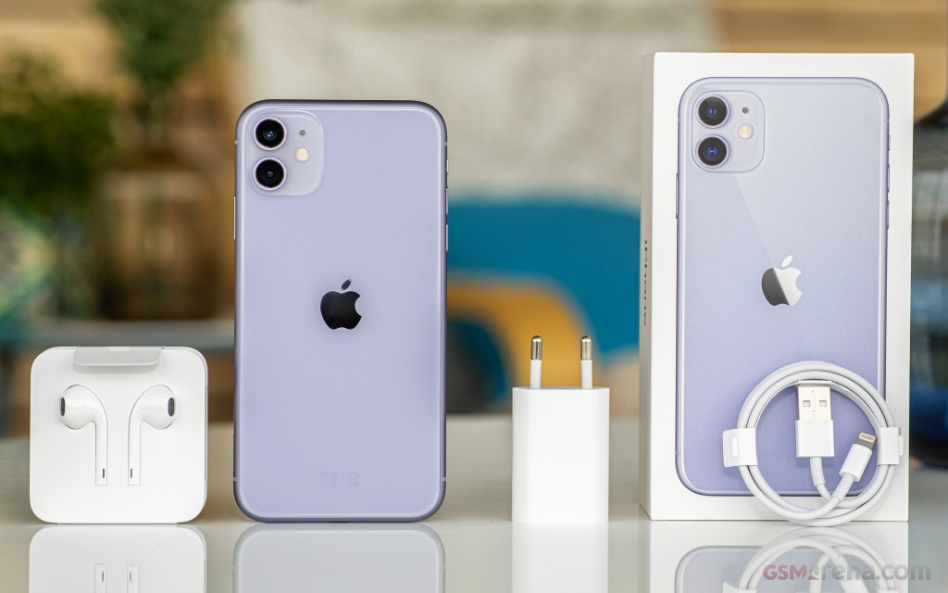

## Apple iPhone 11 price in US $

Apple iPhone 11's retail price in US is $1080 . Official dealers and warranty providers regulate the retail price of Apple mobile products in official warranty.

Retail Price of Apple in USD is $1080.

## Apple iPhone 11 - Updated Design.

Apple is developing and now iPhone 11 got leaked in the wild showing the outline of its new and innovative design. As you can see above in the picture that on the backside of the Apple iPhone 11 horizontal camera is introduced which is consist of dual camera setup and now flashlight is placed between the both camera in the middle that's gonna make Apple iPhone 11's photography quite better and attractive. Along with the camera setup of the device other information is also leaked in which its display is the second one which is 5.65 inches in size. Apple 11 got OLED panels and it is still unconfirmed that from they gonna get these panels because in the past day these panels was coming from Samsung. Apple's iPhone 11 is equipped with the Hexa core processor to perform all the tasks easily. Scratch Resistant Glass is going to protect the display of the new and attractive Apple iPhone's 11. Now display of the device has became scratch resistant and safe from keys and coins. 64 GB of built-in storage of the device is quite enough for user of iPhone 11 by Apple and it can store all your data and software which IOS eleven and it is the home grown software of this brand which is lightest in all ways and capable to execute tasks of Apple iPhone 11 even more smoothly. Apple A11 Bionic is the chipset which this brand has selected for its next generation of flagship. If we talk about the iPhone 11's front side then only single cam is going to come on the front side which is quite powerful and responsive while taking images and you can also shoot videos with that camera.

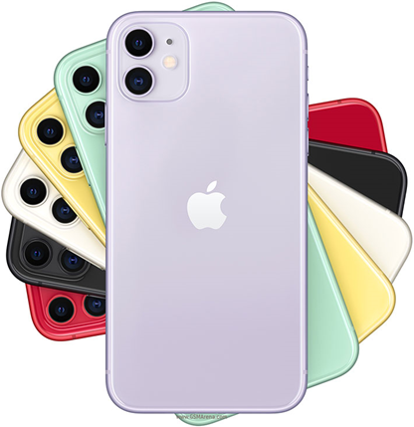

## Apple iPhone 11 detailed specifications

|  |  |  |
| --- | --- | --- |
| **Build** | OS | IOS 13 |
| Dimensions | 150.9 x 75.7 x 8.3 mm |
| Weight | 189 g |
| SIM | Dual Sim, Dual Standby (Nano-SIM) |
| Colors | Black, Green, Yellow, Purple, Red, White |
| **Frequency** | 2G Band | SIM1: GSM 850 / 900 / 1800 / 1900 SIM2: GSM 850 / 900 / 1800 / 1900 |
| 3G Band | HSDPA 850 / 900 / 1700(AWS) / 1900 / 2100 |
| 4G Band | LTE band 1(2100), 2(1900), 3(1800), 4(1700/2100), 5(850), 7(2600), 8(900), 12(700), 13(700), 17(700), 18(800), 19(800), 20(800), 25(1900), 26(850), 28(700), 29(700), 30(2300), 34(2000), 38(2600), 39(1900), 40(2300), 41(2500), 66(1700/2100) |
| **Processor** | Chipset | Apple A13 (7 nm+) |
| **Display** | Technology | Liquid Retina IPS LCD Capacitive Touchscreen, 16M Colors, Multitouch |
| Size | 6.1 Inches |
| Resolution | 828 x 1792 Pixels (~324 PPI) |
| Protection | Scratch-resistant glass |
| Extra Features | 625 nits, Dolby Vision, HDR10, True-tone, Wide color gamut, 120 Hz touch-sensing |
| **Memory** | Built-in | 64/256/512GB Built-in, 4GB RAM |
| Card | No |
| **Camera** | Main | Dual Camera: 12 MP, f/1.8, 26mm (wide), 1/2.55", PDAF, OIS + 12 MP, (ultra wide), Quad-LED dual-tone flash |
| Features | Phase detection, OIS, Geo-tagging, touch focus, face/smile detection, HDR (photo/panorama), Video (2160p@24/30/60fps, 1080p@30/60/120/240fps, HDR, stereo sound rec.) |
| Front | Dual 12 MP TOF 3D camera, HDR, Video (2160p@24/30/60fps, 1080p@30/60/120fps, gyro-EIS) |
| **Connectivity** | WLAN | Wi-Fi 802.11 a/b/g/n/ac/ad, dual-band, hotspot |
| Bluetooth | v5.0 with A2DP, LE |
| GPS | Yes + A-GPS support, & GLONASS, GALILEO, QZSS |
| USB | 2.0, proprietary reversible connector |
| NFC | Yes |
| Data | GPRS, Edge, 3G HSPA, 4G LTE-A, EV-DO Rev.A 3.1 Mbps |
| **Features** | Sensors | Accelerometer, Face ID, Barometer, Compass, Gyro, Proximity |
| Audio | Lightning to 3.5 mm headphone jack adapter, MP3/WAV/AAX+/AIFF/Apple Lossless player, MP4/H.264 player, Speaker Phone |
| Browser | HTML5 (Safari) |
| Messaging | iMessage, SMS (threaded view), MMS, Email, Push Email |
| Games | Built-in + Downloadable |
| Torch | Yes |
| Extra | Dolby Atmos, Dolby Digital Plus, Front/back glass + aluminum frame (7000 series), Active noise cancellation with dedicated mic, IP67 certified - dust and water resistant, Siri natural language commands and dictation, Water resistant up to 1 meter and 30 minutes, Apple Pay (Visa, MasterCard, AMEX certified), Google Maps, Audio/video/photo editor, Voice memo/command/dial, Document editor |
| **Battery** | Capacity | (Li-ion Non removable), 3110 mAh |
| Talk time | up to 17 hrs. |
| Music play | up to 65 hrs. |
|  | - Fast battery charging, USB Power Delivery 3.0, Qi wireless charging, Reverse wireless charging |

|  |  |
| --- | --- |
| **Price** | Price in USD: $1080 |
| **Ratings** | Average Rating is 4.2 stars - based on 231 user reviews. |

Disclaimer

Apple iPhone 11 price in US is updated daily from the price list provided by local shops and dealers but we can not guarantee that the information / price / iPhone 11 Prices on this page is 100% correct (Human error is possible), always visit your local shop for exact cell phone cost & rate. Apple iPhone 11 price US.

